Q1.

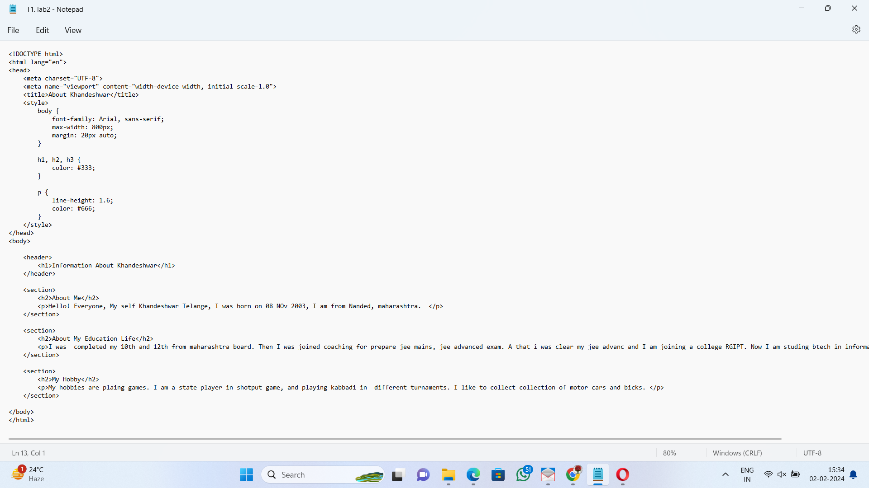

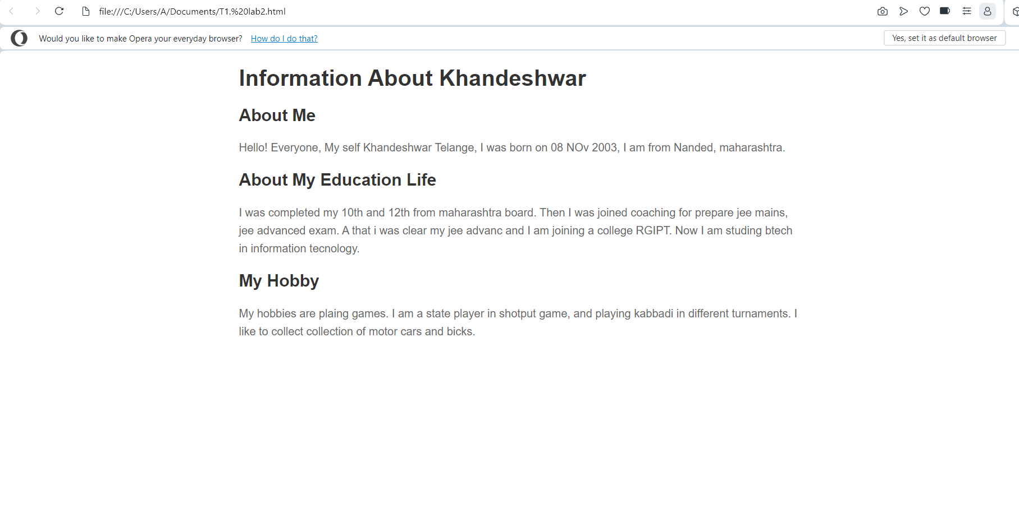

Q2. 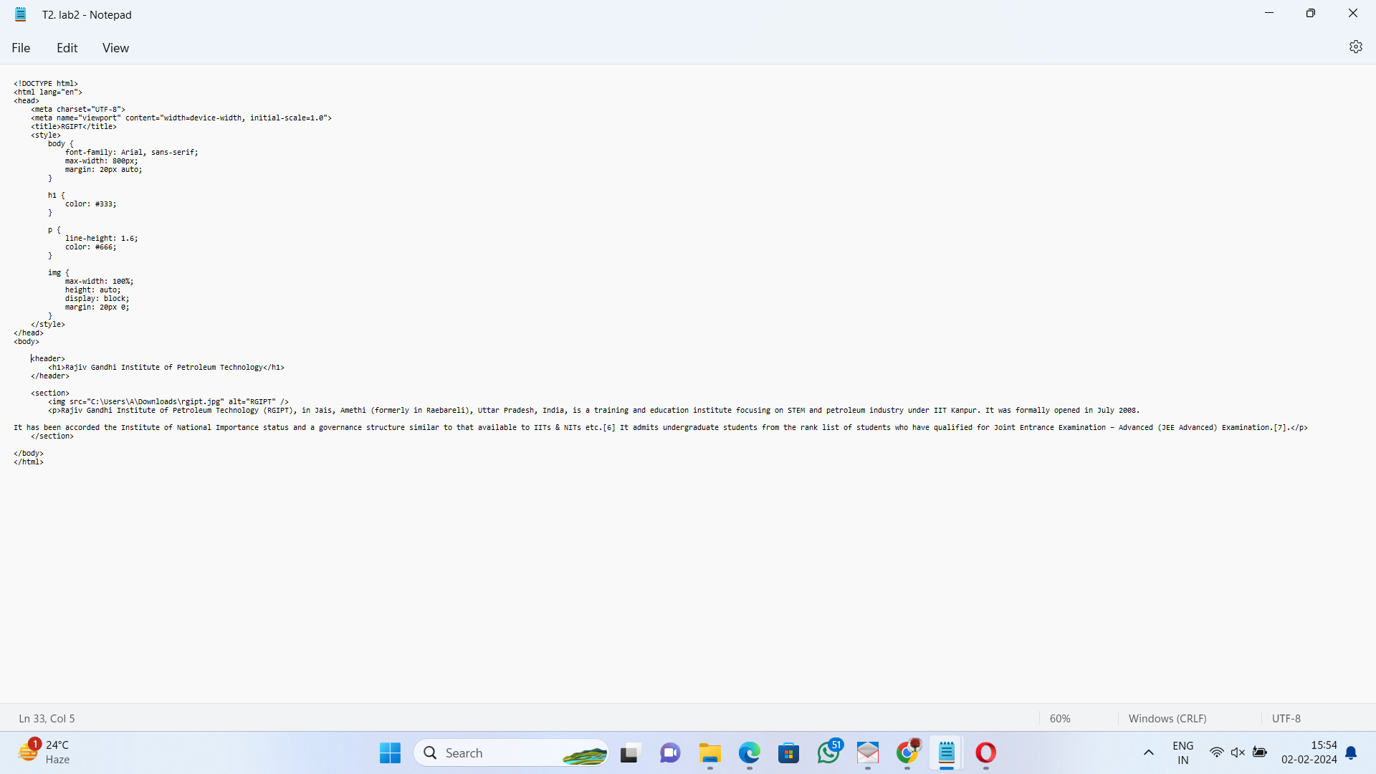



Q3.

<!DOCTYPE html>

<html lang="en">

<head>

<meta charset="UTF-8">

<meta name="viewport" content="width=device-width, initial-scale=1.0">

<title>Languages</title>

</head>

<body>

<header>

<h1>Spoken Languages in Different Countries</h1>

</header>

<section>

<ol type="I">

<li>

<p>India</p>

<ol type="i">

<li>Hindi</li>

<li>English</li>

</ol>

</li>

<li>

<p>France</p>

<ol type="i">

<li>French</li>

<li>German</li>

</ol>

</li>

<li>

<p>Russia</p>

<ol type="i">

<li>Russian</li>

<li>English</li>

</ol>

</li>

</ol>

</section>

</body>

</html>

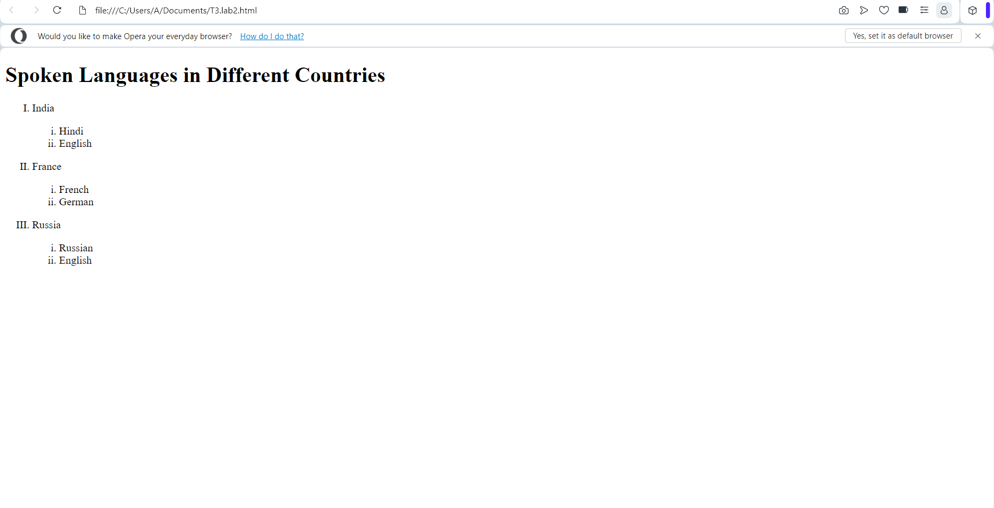

Q4.

!DOCTYPE html>

<html lang="en">

<head>

<meta charset="UTF-8">

<meta name="viewport" content="width=device-width, initial-scale=1.0">

<title>Countries and Capitals</title>

<style>

table {

width: 50%;

border-collapse: collapse;

margin: 20px;

}

th, td {

border: 1px solid black;

padding: 8px;

text-align: left;

}

</style>

</head>

<body>

<table>

<thead>

<tr>

<th>Column 1</th>

<th>Column 2</th>

</tr>

</thead>

<tbody>

<tr>

<td>

<ul>

<li>United States</li>

<li>Japan</li>

<li>Brazil</li>

<li>France</li>

<li>Australia</li>

</ul>

</td>

<td>

<ol>

<li>Washington, D.C.</li>

<li>Tokyo</li>

<li>Brasília</li>

<li>Paris</li>

<li>Canberra</li>

</ol>

</td>

</tr>

</tbody>

</table>

</body>

</html>

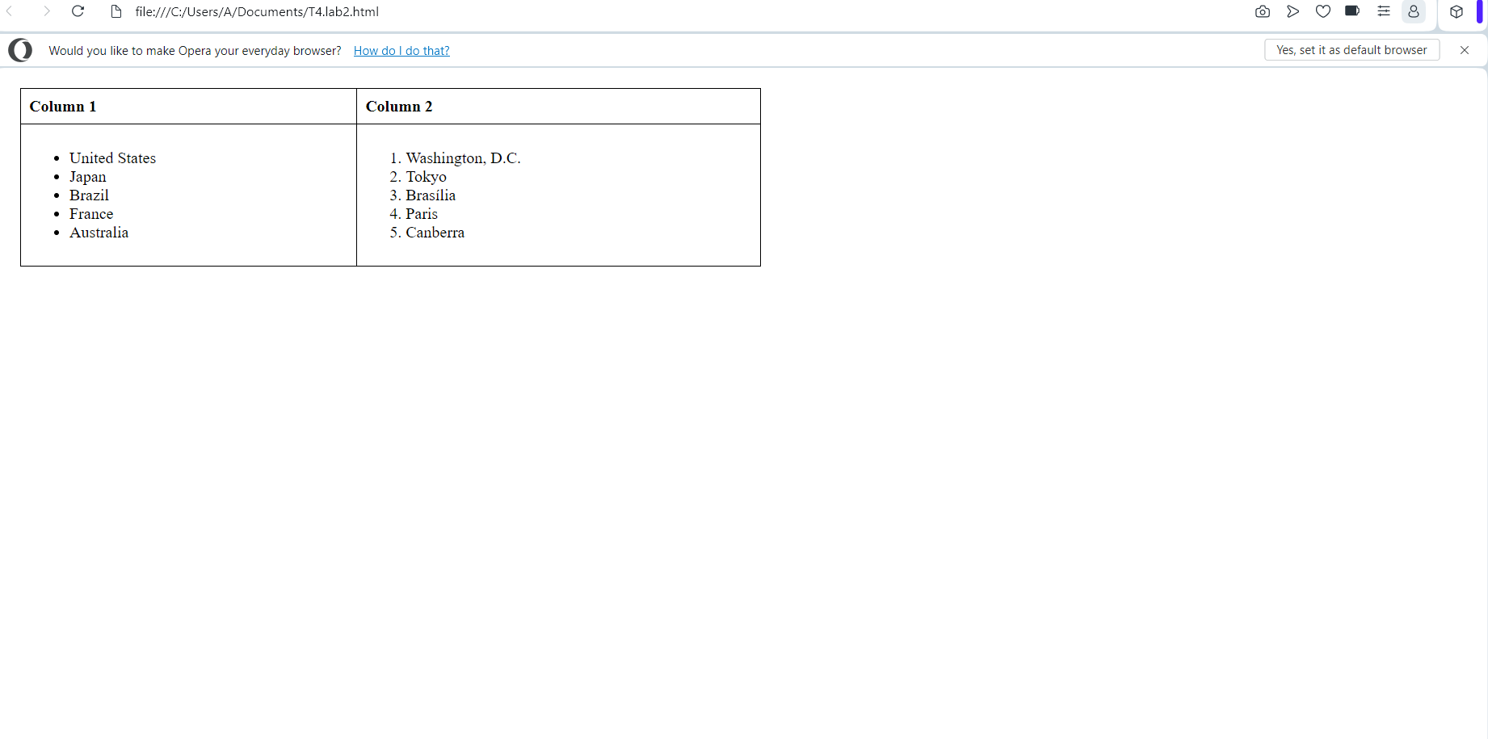

<!DOCTYPE html>

<html lang="en">

<head>

<meta charset="UTF-8">

<meta name="viewport" content="width=device-width, initial-scale=1.0">

<title>Country Politicians</title>

<style>

table {

border-collapse: collapse;

width: 100%;

}

th, td {

border: 1px solid black;

padding: 8px;

text-align: left;

}

th {

background-color: #f2f2f2;

}

</style>

</head>

<body>

<table>

<thead>

<tr>

<th>Country</th>

<th colspan="2">Politicians</th>

</tr>

</thead>

<tbody>

<!-- Row 1 -->

<tr>

<!-- Column 1: Country -->

<td rowspan="2">Turkmenistan</td>

<!-- Column 2: Politicians -->

<td>President</td>

<td>Gurbanguly Berdimuhamedow</td>

</tr>

<!-- Row 2 -->

<tr>

<td>Vice-President</td>

<td>Raşit Meredow</td>

</tr>

<!-- Row 3 -->

<tr>

<td rowspan="2">Eritrea</td>

<td>President</td>

<td>Isaias Afwerki</td>

</tr>

<!-- Row 4 -->

<tr>

<td>Vice-President</td>

<td>None</td>

</tr>

</tbody>

</table>

</body>

</html>

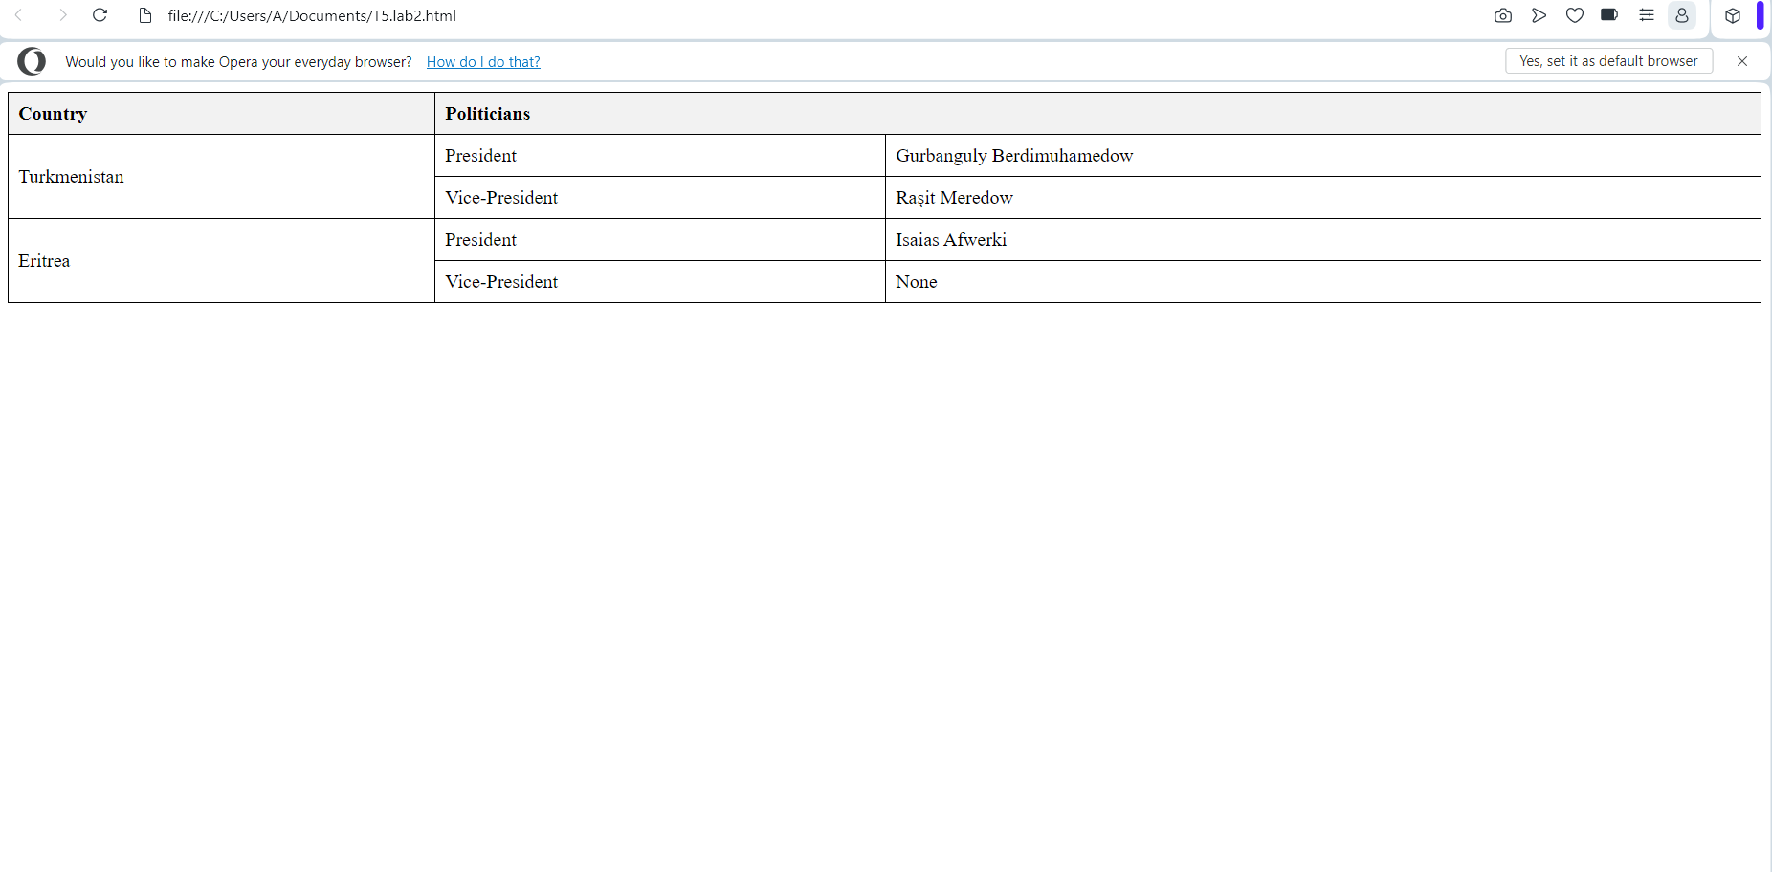

Q6.

!DOCTYPE html>

<html lang="en">

<head>

<meta charset="UTF-8">

<meta name="viewport" content="width=device-width, initial-scale=1.0">

<title>My Favorite Websites</title>

</head>

<body>

<h1>Check Out My Favorite Websites</h1>

<ul>

<li><a href="https://www.doubtnut.com/" target="_blank">Website 1</a></li>

<li><a href="https://www.amazon.in/" target="_blank">Website 2</a></li>

<li><a href="https://www.flipkart.com/" target="_blank">Website 3</a></li>

<li><a href="https://www.zomato.com/" target="_blank">Website 4</a></li>

</ul>

</body>

</html>

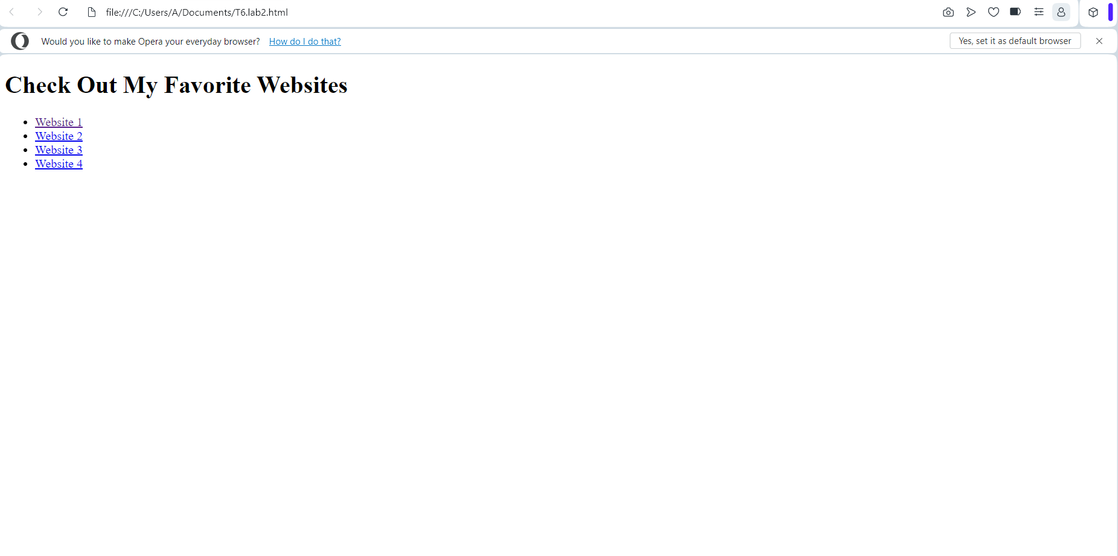

Q7.

!DOCTYPE html>

<html lang="en">

<head>

<meta charset="UTF-8">

<meta name="viewport" content="width=device-width, initial-scale=1.0">

<title>Website to Jump to the Top</title>

</head>

<body>

<header>

<h1>Content Below</h1>

</header>

<section>

Hello, my name is Khandeshwar Telange. I am studying Information Technology in RGIPT.

<p><a href="#top">Jump to Top</a></p>

</section>

<footer>

<a id="top"></a>

</footer>

</body>

</html>

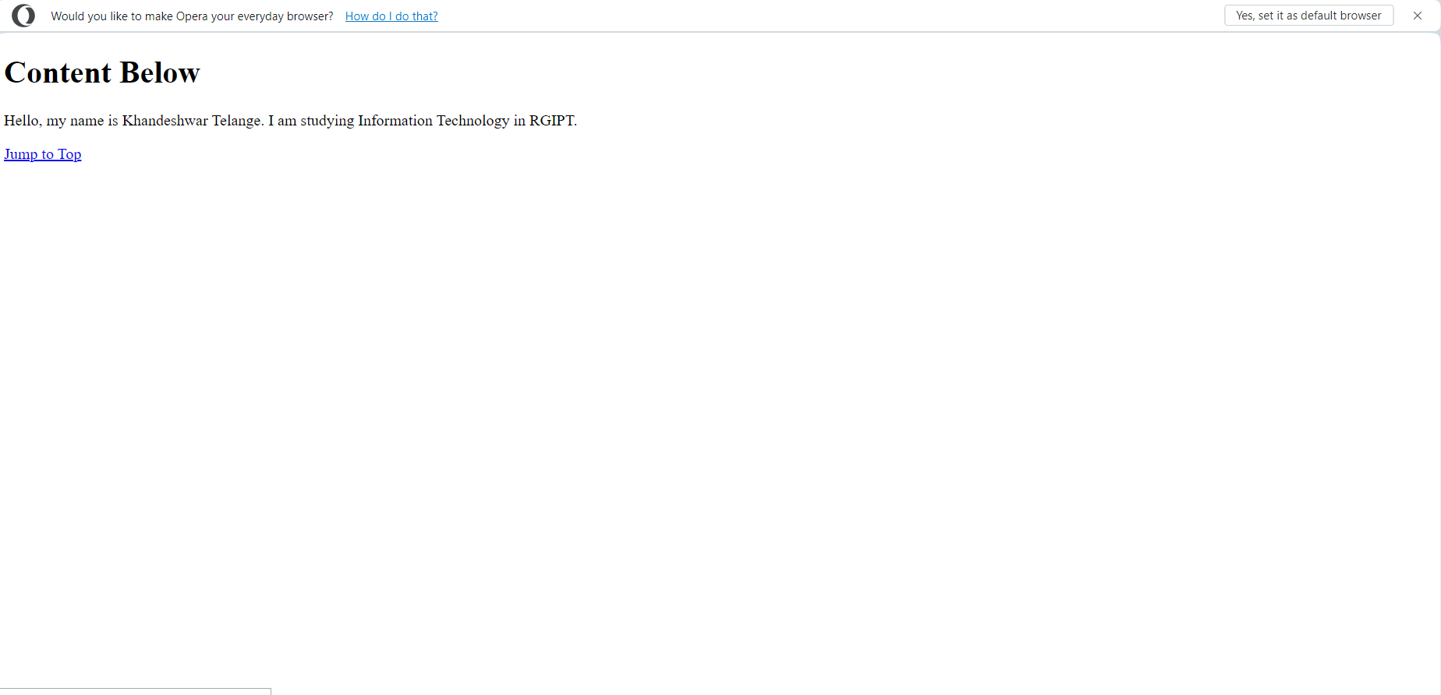

Q8.

<!DOCTYPE html>

<html lang="en">

<head>

<meta charset="UTF-8">

<meta name="viewport" content="width=device-width, initial-scale=1.0">

<title>Website to Jump to Top and Bottom</title>

</head>

<body>

<header>

<h1>Content Below</h1>

</header>

<section>

Hello, my name is Khandeshwar Telange. I am studying Information Technology in RGIPT.

<p><a href="#top">Jump to Top</a></p>

</section>

<footer>

<a id="bottom"></a>

<p><a href="#bottom">Jump to Bottom</a></p>

</footer>

</body>

</html>

Q9.

<!DOCTYPE html>

<html lang="en">

<head>

<meta charset="UTF-8">

<meta name="viewport" content="width=device-width, initial-scale=1.0">

<title>Image with Border</title>

<style>

img {

border: 2px solid #000; /* Border size and color */

width: 200px; /* Width of the image */

height: 200px; /* Height of the image */

}

</style>

</head>

<body>

<h1>Image with Border</h1>

<img src="C:\Users\A\Downloads\rgipt.jpg" alt="RGIPT">

</body>

</html>

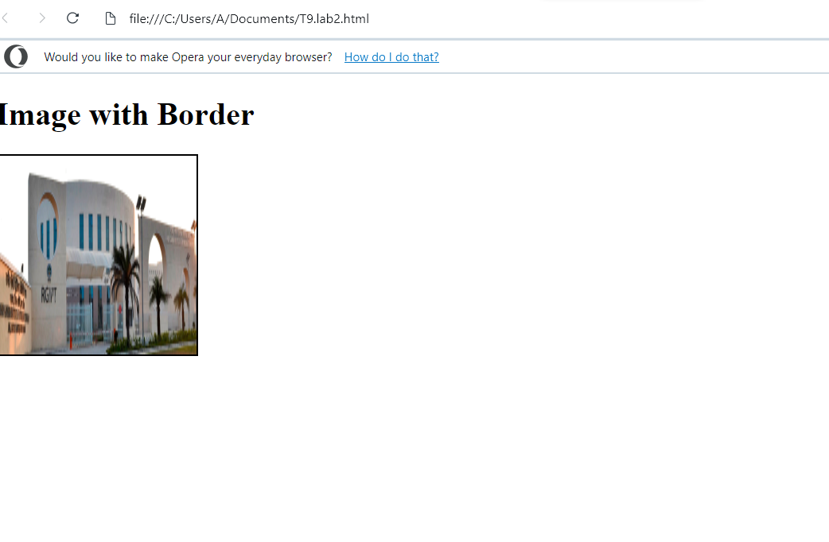

Q10.

<!DOCTYPE html>

<html lang="en">

<head>

<meta charset="UTF-8">

<meta name="viewport" content="width=device-width, initial-scale=1.0">

<title>Image Gallery</title>

</head>

<body>

<header>

<h1>Image Gallery</h1>

</header>

<section>

<figure>

<img src="C:\Users\A\Downloads\P1.jpg"alt="1" width="300" height="200">

</figure>

<br><br>

<figure>

<img src="C:\Users\A\Downloads\P2.jpg" alt="2" width="300" height="200">

</figure>

<br><br>

<figure>

<img src="C:\Users\A\Downloads\P3.jpg" alt="3" width="300" height="200">

</figure>

<br><br>

0

</section>

</body>

</html>

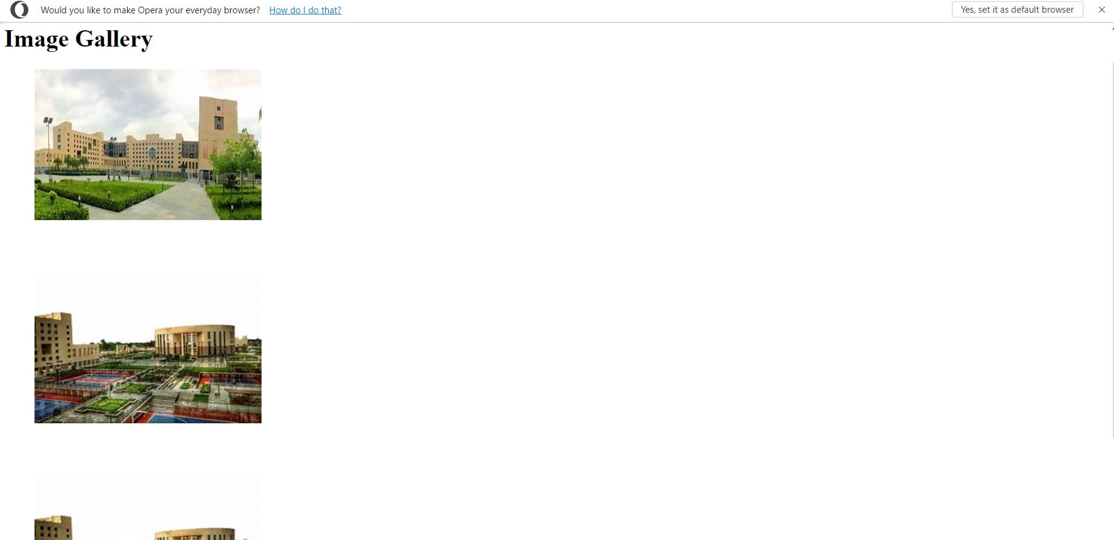

Q11.

<!DOCTYPE html>

<html lang="en">

<head>

<meta charset="UTF-8">

<meta name="viewport" content="width=device-width, initial-scale=1.0">

<title>Clickable Image made by KHANDESHWAR</title>

</head>

<body>

<header>

<h1>Clickable Image made by KHANDESHWAR</h1>

</header>

<section>

<a href="https://www.youtube.com" target="_blank">

<img src="C:\Users\A\Downloads\P3.jpg" alt="RGIPT" width="300" height="200">

</a>

</section>

</body>

</html>

